
September 30th – October 4th
Theme: Pumpkins
Review Concepts | New Concepts
Phonemic Focus: A-C  Science: Pumpkin Parts  Math: Number 3  Song: Cinco Calabazas | Vocabulary: Shapes in Spanish  Letter D

Developmental Area | Objective | Day #1 | Day #2 | Day #3
Spiritual/Relational  Development  Extra Activities:  Remarkable Friendship of Mr. Cat an Mrs. Rat | Bible Focus: Jesus’ Gift of Salvation  Relational Focus:  Giving to Others | Jesus’ story of salvation Bible story Review | 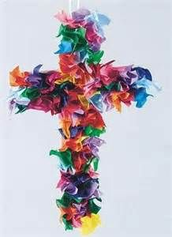  Tissue paper cross craft | Sing Along Bible Songs
Art/Fine Motor  Development  Extra Activities:  1. Fall puzzle | Extra Activities:  1. Paint White pumpkin  2. Dissect Pumpkin again | Having to use the tweezers to put the pumpkin seeds in the pumpkin baskets | Paint the pumpkin seeds and white pumpkin | 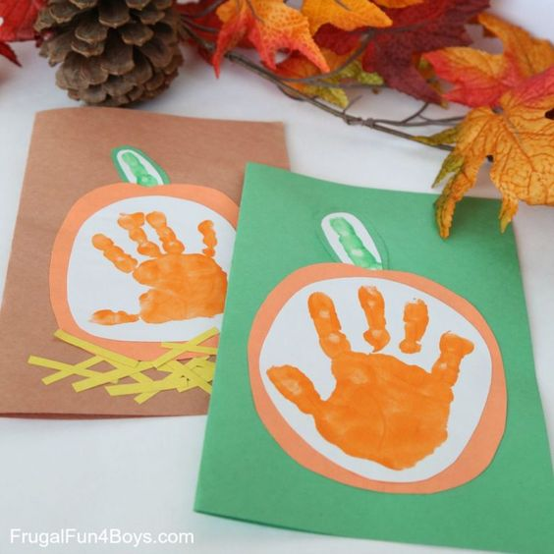  Give Pumpkin craft away
Social Studies/Sensory | None | None | None | Pumpkin seed sensory letter find
Phonemic Awareness &  Guided Reading  Extra Practice Activities:  1. Pencil alphabet puzzles | Books:  1. Too Many Pumpkin: Linda White  2. El Circulo de las Calabazas  Phonemic Focus:  - Letter D | Read the book El Circulo & life cycle of the pumpkin s  Phonemic Focus:  Review letters: Pumpkin Patch match and puzzles | Finish El Circulo mini-book of the pumpkin  Phonemic Focus:  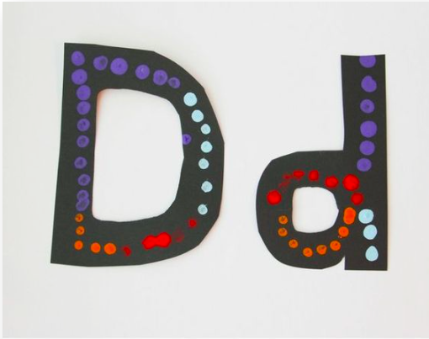  Introduce D and dot paint craft | Read Too Many Pumpkins  Phonemic Focus:  Letter D sticker and dot worksheet
AM Planned Play Activities
PM Activities and Exposure Skills
Developmental Area | Objective | Day #1 | Day #2 | Day #3
Sing Along | Cinco Calabazas  Vocabulary Review:  1. Cansada  2. Enojada  3. Frustrada  4. Asustada  5. Soprendida | Play the song and reenact it with the pumpkins on the pocket chart | Play with the pumpkins on the anchor chart and do activity | Sing song and use our play pumpkins to reenact the song
Math and Numbers Development | Math Concept:  Spanish Shapes  Identify Number 3 | Math Concept:  Review Spanish shapes with the pumpkin cards  Numbers Review #1-3  To review the numbers and letter D play the donuts, button with dice game | Math Concept:  Digging for shapes sensory in rice  Numbers  Review Numbers 1-3 and sing number songs | Math Concept:  Pumpkin seed shape mats.  Numbers  Make number 1-3 with foam shapes
Library Books | Read last weeks library book books | Library Books | Library Books | Library Books
Dramatic Play |  | Pumpkin and Leaf play | Pumpkin and Leaf Play

